**56. Spring REST – Overview**

**In Spring Rest will learn**:

1. Create REST APIs / Web Services with Spring
2. Discuss REST concepts, JSON and HTTP messaging
3. Install REST client tool: Postman
4. Develop REST APIs / Web Services with **@RestController**
5. Build a CRUD interface to the database with Spring REST

**Details info about Spring**: <https://spring.io/projects/spring-framework>

**Business Problem**:

* Build a client app that provides the weather report for a city
* Need to get weather data from an external service

**Application Architecture**:

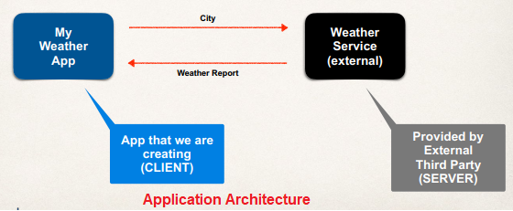

**Questions**:

1. How will we connect to the Weather Service?
2. What programming language do we use?
3. What is the data format?

**Answer**:

1. **How will we connect to the Weather Service?**
   1. We can make REST API calls over HTTP
   2. **REST**: **RE**presentational **S**tate **T**ransfer
   3. Lightweight approach for communicating between applications
2. **What programming language do we use?**
   1. REST is language independent
   2. The client application can use ANY programming language
   3. The server application can use ANY programming language
3. **What is the data format?**
   1. REST applications can use any data format
   2. Commonly see XML and JSON
   3. JSON is most popular and modern
   4. **J**avaScript **O**bject **N**otation

**Multiple Client Apps**:

REST API or REST web service can provide the data for multiple Clint app.

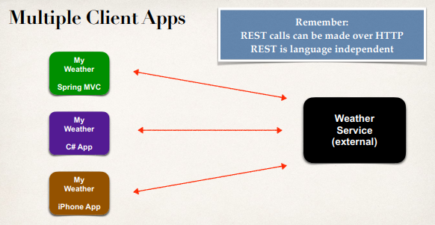

**Where to find REST APIS**:

**Link**: <https://www.programmableweb.com/>

In the above link they provide multiple API.

**What do we call it (API)**?

This is a common question, what do we call it? REST API, or RESTful API, or REST Web Services, or RESTful Web Services, or REST Services, or RESTful Services. Generally, they all mean the same thing. They are not different.

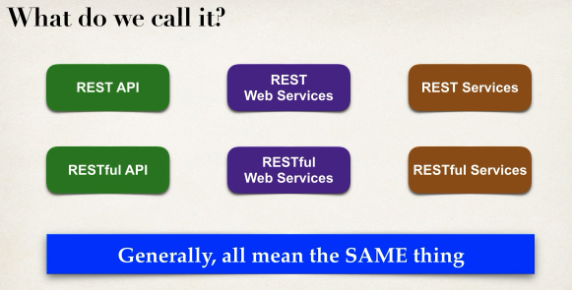

56. Spring REST - Overview